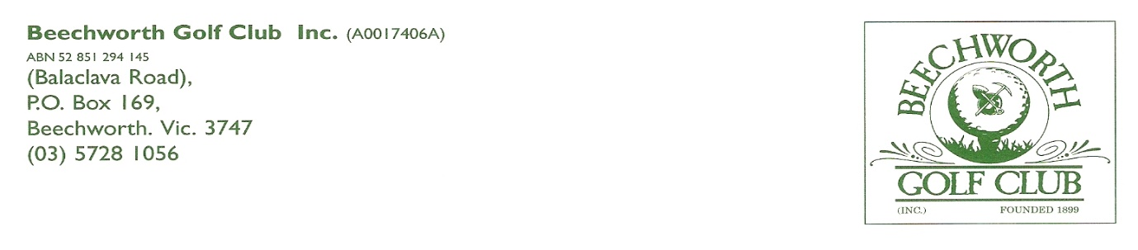

**BEECHWORTH GOLF CLUB INCORPORATED**

**JUNIOR MEMBERSHIP APPLICATION FORM**

**2024/25**

|  |  |
| --- | --- |
| **Title** (please circle) | **Mr Mrs Ms** |
| **First Name** |  |
| **Surname** |  |
| **Date of Birth** |  |
| **Residential Address** |  |
| **Postal Address** (if different) |  |
| **Home Phone Number** |  |
| **Mobile Phone Number** |  |
| **Email Address** |  |
| **Previous Golf Club** (if applicable) |  |
| **Current Golf Link Number** |  |
| **Current Handicap** |  |

**2024/25 MEMBERSHIP TYPES AND FEES**

* Adult Member – $150
* Country Member – $100 (must reside outside 30km – Golf Link)
* Country Member - $75 (must reside outside 30km – No Golf Link)
* Recreational Pass - $75 (No competition – no Golf Link)
* Summer Member – $75 (Twilight Competition during Daylight Savings Time – No Golf Link))
* Junior Member – $10 (must be under the age of 18)

**MEMBER DECLARATION**

I, the person whose details appear above, wish to apply to become a member of the Beechworth Golf Club Incorporated in the following category (please circle):

|  |  |  |  |  |
| --- | --- | --- | --- | --- |
| **Adult ($150)** | **Country with Golf Link**  **$100** | **Country with No Golf Link ($ 75)** | **Recreational ($75) Summer ($75)** | **Junior ($10)** |

I agree to support the values and missions of the Beechworth Golf Club and the purposes of the North East District Golf Association (NEDGA), and in the event that my membership application is accepted by the Club, I agree to be bound by the Rules of the Association that are in place whilst I remain a member.

|  |  |
| --- | --- |
| **Signature** |  |
| **Date** |  |

**Parent / Guardian Signature ____________________________________________________**

**MEMBER ACCEPTANCE / NOMINATION**

I, a current member of the association, nominate the above named person for membership of the Beechworth Golf Club Incorporated.

|  |  |  |
| --- | --- | --- |
| **Current Member Name** |  |  |
| **Signature** |  |  |
| **Date** |  |  |

I, a current member of the association, second the above named person for membership of the Beechworth Golf Club Incorporated.

|  |  |
| --- | --- |
| **Current Member Name** |  |
| **Signature** |  |
| **Date** |  |

**PAYMENT**

Membership fees for the 2024/25 season are due by **March 31, 2024** and can be paid by:

* Direct debit to the club’s bank account – BSB 803-070, Account number 89952 (please put your name and membership type against your deposit)
* Making out a cheque to Beechworth Golf Club Incorporated
* Paying in cash by coming up to the Club during competition times

To ensure that the Club can bring its records up to date, please complete all sections of this Application Form and return it via:

* Email: [contactus@beechworthgolfclub.com](mailto:contactus@beechworthgolfclub.com)
* Post: PO Box 169, Beechworth, VIC, 3747
* In person: Drop it off in the office or hand it to one of our Committee members

**SECRETARY / TREASURER USE ONLY**

|  |  |  |
| --- | --- | --- |
| **Date Received** | **Date of Committee Consideration** | **Date of Acceptance / Notification** |
|  |  |  |